

**Scotch College**

**Semester One Examination, 2015**

**Question/Answer Booklet**

**MATHEMATICS METHODS (Yr 11)**

**Section Two:**

**Calculator Assumed**

**Teacher (please circle):**

**J Fletcher R Foster P Newman M Zuidersma**

**Name:**

**Time allowed for this section**

Reading time before commencing work: 10 minutes

Working time for this section: 100 minutes

**Material required/recommended for this section**

***To be provided by the supervisor***

This Question/Answer Booklet

Formula Sheet

***To be provided by the candidate***

Standard items: pens, pencils, pencil sharpener, eraser, correction fluid, ruler, highlighters

Special items: notes on two unfolded sheets of A4 paper, up to three approved calculators

**Important note to candidates**

No other items may be used in this section of the examination. It is **your** responsibility to ensure that you do not have any unauthorised notes or other items of a non-personal nature in the examination room. If you have any unauthorised material with you, hand it to the supervisor **before** reading any further.

**Structure of this paper**

|  |  |  |  |  |  |
| --- | --- | --- | --- | --- | --- |
| Section | Number of questions available | Number of questions to be answered | Working time (minutes) | Marks  available | Weighting |
| Section One:  Calculator-free | 8 | 8 | 50 | 50 | 35 |
| Section Two  Calculator-assumed | 13 | 13 | 100 | 100 | 65 |
|  |  |  |  | 150 | 100 |

**Instructions to candidates**

1. Write your answers in the spaces provided in this Question/Answer Booklet. Spare pages are included at the end of this booklet. They can be used for planning your responses and/or as additional space if required to continue an answer.

* + Planning: If you use the spare pages for planning, indicate this clearly at the top of the page.
  + Continuing an answer: If you need to use the space to continue an answer, indicate in the original answer space where the answer is continued, i.e. give the page number. Fill in the number of the question(s) that you are continuing to answer at the top of the page.

2. **Show all your working clearly.** Your working should be in sufficient detail to allow your answers to be checked readily and for marks to be awarded for reasoning. Incorrect answers given without supporting reasoning cannot be allocated any marks. For any question or part question worth more than two marks, valid working or justification is required to receive full marks. If you repeat an answer to any question, ensure that you cancel the answer you do not wish to have marked.

3. It is recommended that you **do not use pencil** except in diagrams.

**Section Two: Calculator-assumed (100 Marks)**

This section has **thirteen (13)** questions. Answer **all** questions. Write your answers in the space provided.

Spare pages are included at the end of this booklet. They can be used for planning your responses and/or as additional space if required to continue an answer.

* + Planning: If you use the spare pages for planning, indicate this clearly at the top of the page.
  + Continuing an answer: If you need to use the space to continue an answer, indicate in the original answer space where the answer is continued, i.e. give the page number. Fill in the number of the question(s) that you are continuing to answer at the top of the page.

Working time for this section is 100 minutes.

**9. [4 marks]**

Consider the triangle ABC, where AB = 10 cm , BC = 7 cm and °.

ˆ

1. Find the two possible values of  to the nearest degree.  **[3]**

(b) Hence, find to the nearest degree, given that it is acute. **[1]**

**10. [6 marks]**

A boat leaves its port, P, and sails for 28km on a bearing of 025° to a point A. At A it changes course and then sails on a bearing of 310° for 42km to another port Q.

(a) Draw a diagram to represent this information **[1]**

(b) Calculate the direct distance from P to Q. **[2]**

1. Calculate the bearing of Q from P.  **[3]**

**11. [6 marks]**

Solve the following using the quadratic formula, giving your answer to 2 decimal places where appropriate. **Working needs to be shown**.

1.  **[3]**
2.  **[3]**

**12. [6 marks]**

Find the radius and centre of the circles given by

(a)   **[2]**

(b)   **[4]**

1. **[7 marks]**

The height, *h* metres above the water, of a stone thrown off a bridge is modelled by the function ,



where *t* is the time in seconds after the stone is thrown.

1. What is the initial height from which the stone is thrown? **[1]**

(b) What is the maximum height reached by the stone and when does it reach this height? **[2]**

(c) For what length of time is the height of the stone greater then 26m?

**[3]**

(d) How long does it take for the stone to hit the water below the bridge?

**[1]**

1. **[10 marks]**

For the functions  ,  , 

(a) State the natural domain and the corresponding range for each of the following

(i)  **[2]**

(ii)  **[2]**

1.   **[2]**
2. Determine  **[2]**

(c) Solve for *p* if  **[2]**

**15. [4 marks]**

1. State the rule for the following sine function (where x is in degrees) **[2]**

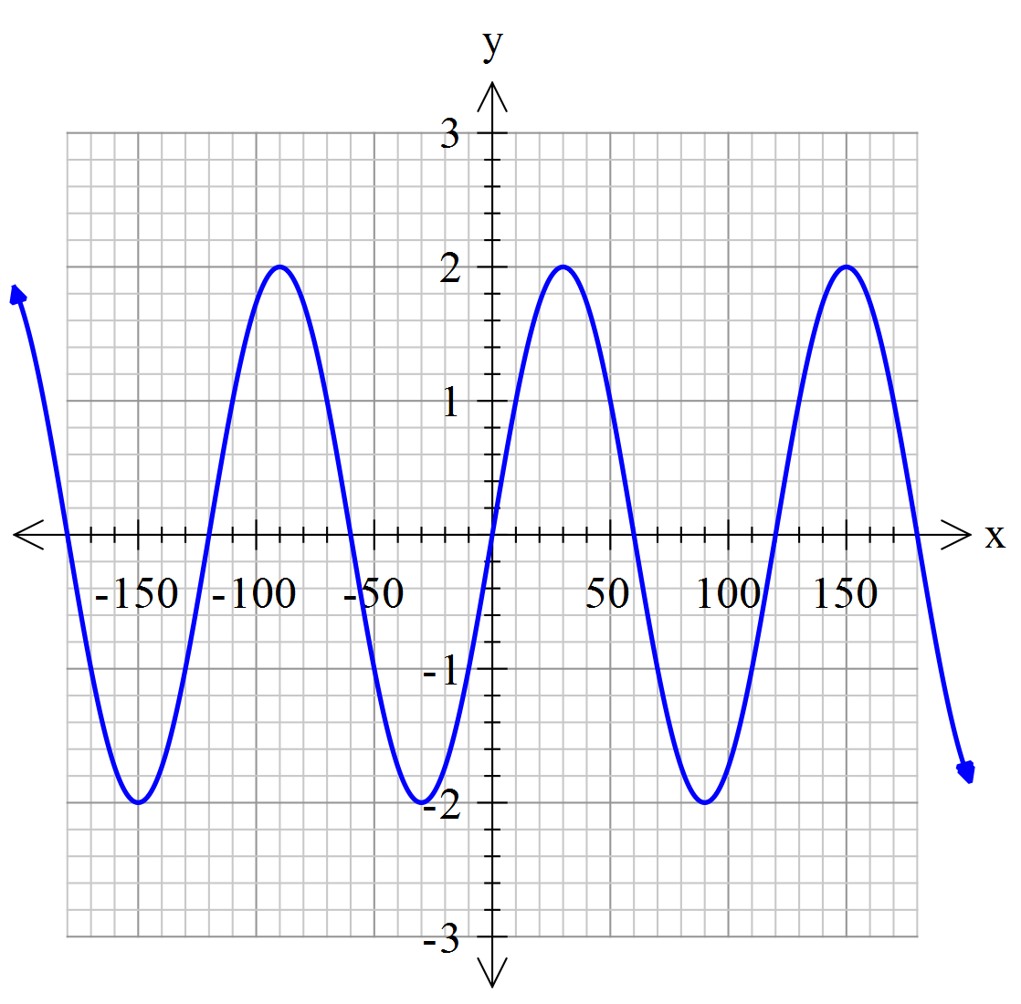

1. State the rule for the following cosine function (where x is in degrees) **[2]**

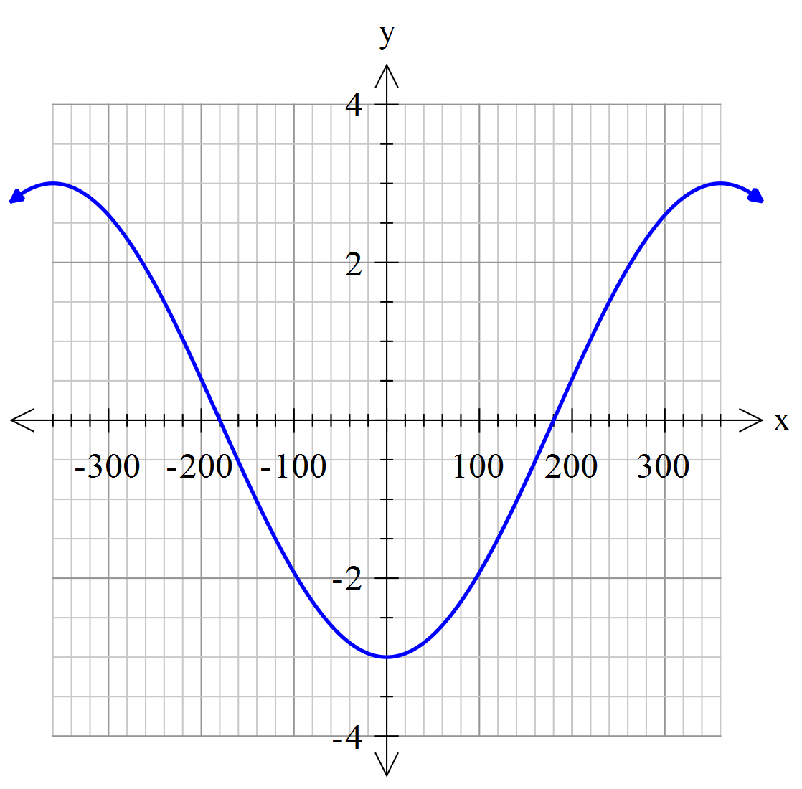

**16. [12 marks]**

A circle has its centre at *C*(-1,3) and a radius of 5 units.

1. Find the equation of the circle. **[2]**
2. The line 3*x*-*y*+1=0 intersects the circle at two points. Find algebraically the coordinates of the two points. **[5]**
3. Let these points be *X* and *Y*. (Let the point with the smallest x-coordinate be X.) Find the coordinates of point *Z* such that *YZ* is a diameter of the circle. **[2]**
4. Show that =90°. **[3]**

**17. [14 marks]**

(a) Find the rule for each of the following functions.

(i)  **[2]**

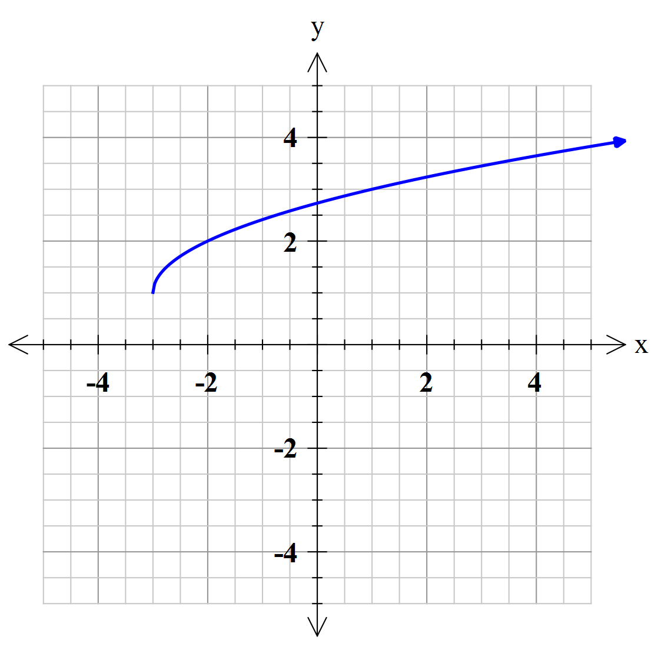

(ii) **[3]**  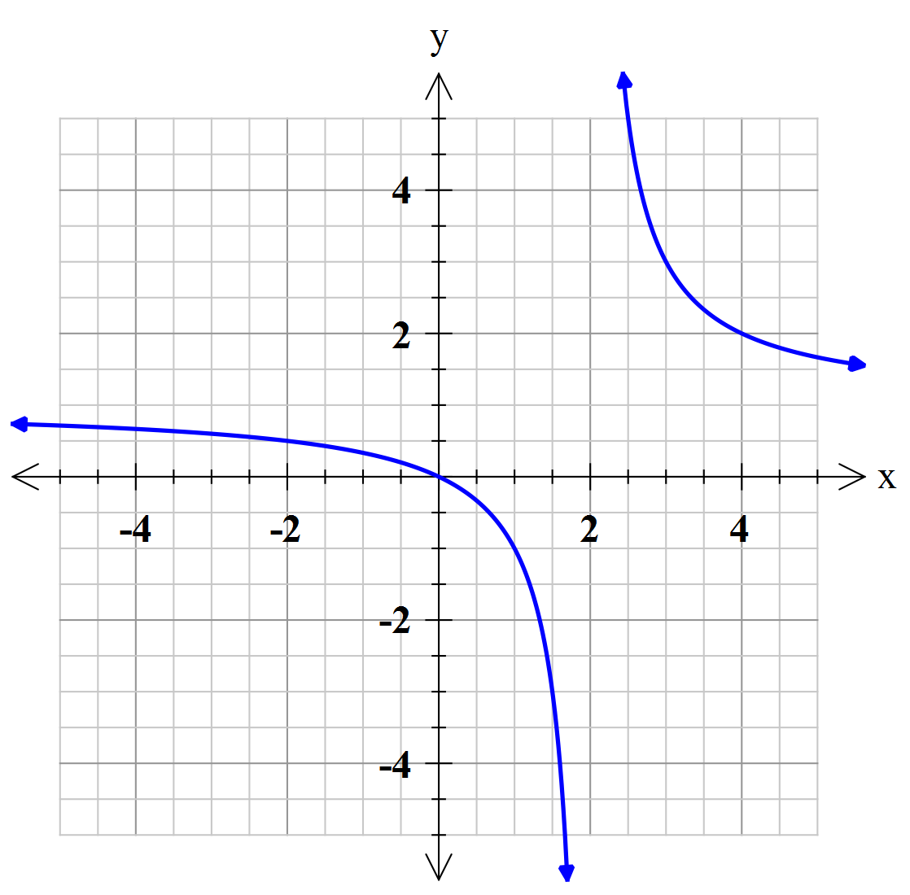

(iii) **[3]**

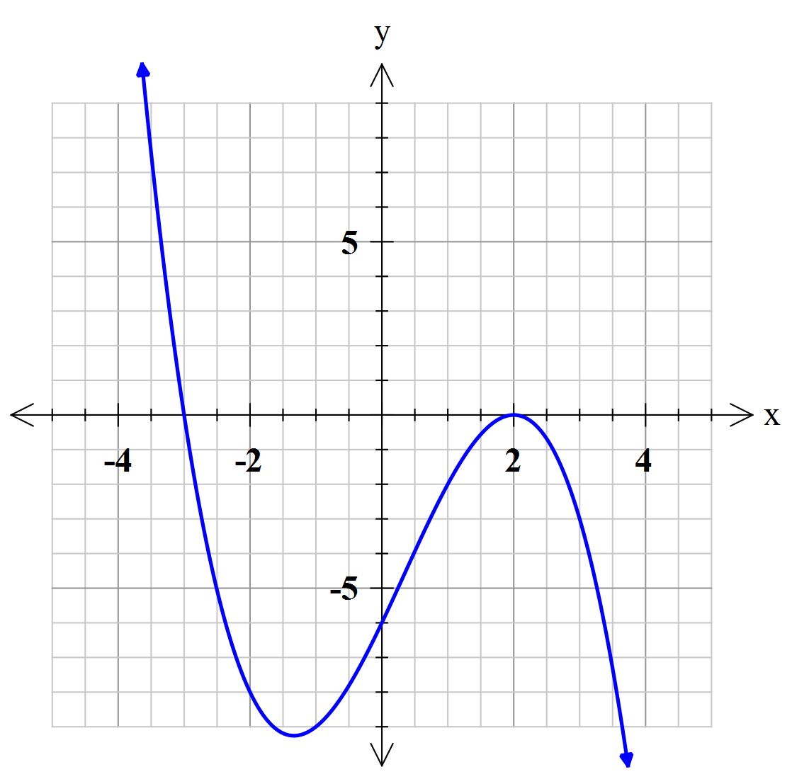

(b)Find the equation of the quadratic function with turning point (1, 4) and an *x*-intercept of -1. **[3]**

1. Find the equation of the cubic function with only one x-intercept at (-2,0), which is also a horizontal point of inflection, and a y-intercept at (0,24). **[3]**

**18. [8 marks]**

(a) The quadratic equation 4*x2 +* 3*kx +* 9 *=* 0 has exactly one solution for *x.* Find the value(s) of *k.* **[4]**

1. Triangles ABC and ABD are right triangles.  and .

Prove that **.  **[4]**

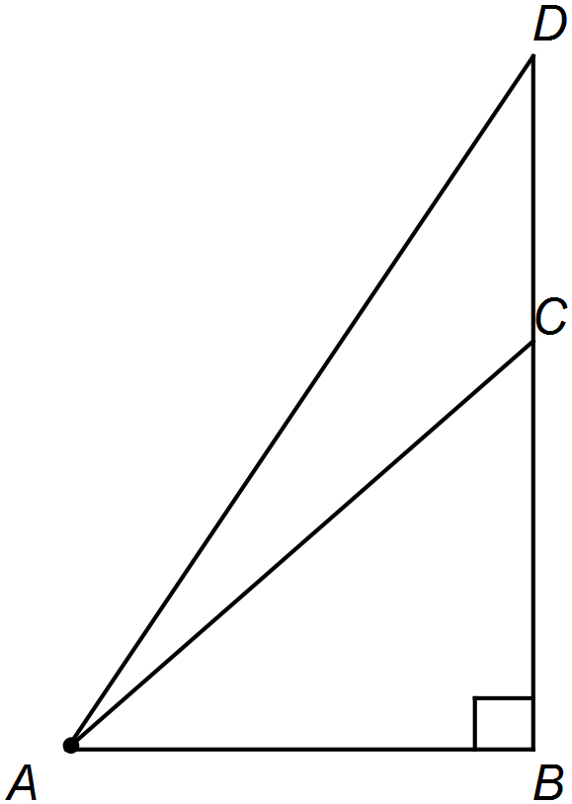

**19. [6 marks]**

State the period and amplitude for each of the following with x in degrees.

1. *y = - cos2x*  **[2]**
2. *y = 4 tan (0.5x)*   **[2]**
3. *y = 3sin *  **[2]**

**20. [6 marks]**

The depth of a tidal pool on a particular day could be modelled by the function  where ***h*** is the depth in metres and ***t*** gives the hours since midnight.

1. What was the depth at midnight? [1]
2. What was the depth at 6:00 a.m.? [1]
3. What was the earliest time at which the depth was 2m? [2]
4. At what times was the pool at maximum depth? [2]

**21. [11 marks]**

Two circular table mats, one of radius 12 cm and the other of radius 8 cm, are laid on a table with their centres 16 cm apart.

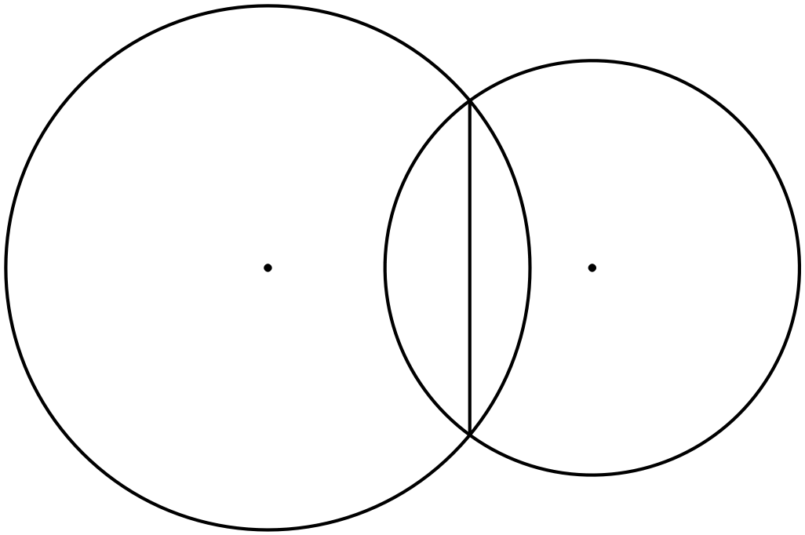

1. Determine

(i) the length of the common chord **[4]**

1. the area common to the two mats. **[4]**
2. A circle centre O and radius 6 cm, has points A and B on its circumference. The minor sector AOB has an area of 45cm2. Determine the arc length of minor sector AOB. **[3]** [3]

**END OF EXAM**

**EXTRA WORKING PAGES**

**EXTRA WORKING PAGES**

**EXTRA WORKING PAGES**

|  |  |  |
| --- | --- | --- |
| **Question** | **Marks** | **Result** |
| 9 | 4 |  |
| 10 | 6 |  |
| 11 | 6 |  |
| 12 | 6 |  |
| 13 | 7 |  |
| 14 | 10 |  |
| 15 | 4 |  |
| 16 | 12 |  |
| 17 | 14 |  |
| 18 | 8 |  |
| 19 | 6 |  |
| 20 | 6 |  |
| 21 | 11 |  |
| **Total** | **100 marks** |  |